Word Graffiti

In your visual journal, create graffiti art for each of the following words:

- simple machine  - work  - force  - friction  - gear  - compound machine  - effort  - load | - fulcrum  - wheel  - axle  - pulley  - screw  - inclined plane  - roller  - lever
Criteria:
- Please put 4 words on each page
- Each word must be legible
- Try to avoid too many simple lines. Make it look interesting and make it big enough that it is easy to read.
- The way you have drawn the word must show the meaning (see examples below)
- Each word must be coloured
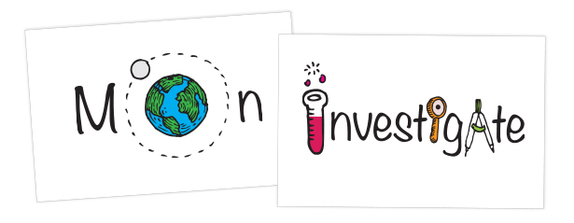
- Be creative!

